**TURKU MARKET APPLICATION**

**PROJECT PLAN**

|  |  |  |  |
| --- | --- | --- | --- |
| |  | | --- | | Head of the project: Phan Hong Duc | |  | |
|  |  | |
|  |  |  |
|  |  |  |
| |  | | --- | | Date: 8 March, 2017 | |  |  |

Contents

1. Project overview 4

1.1. Project scope 4

1.2. Major software functions 4

1.3. Flea Market 4

1.4. Information of supermarkets 4

1.5. Future 4

1.6. Distribution 4

1.7. Earnings model 5

1.8. Marketing 5

1.9. Deliverables 5

2. Management Structure 5

2.1. Project Lifecycle 5

2.2. Organizational Boundaries and Interfaces 6

2.2.1 Roles and Responsibility 6

2.2.2 Staffing 6

2.3. Risk Management 7

2.3.1 Top Risks List 7

2.3.2 Risk Mitigation Strategy: 7

3. Planning and Control 7

3.1. Estimation Method 7

3.2. Resource Identification 8

3.2.1 Staff 8

3.2.2 Time 8

3.2.3 Cost 8

3.3. Schedule 8

3.4. Tracking and control 8

3.5. Milestones 9

3.5.1 Major Milestones 9

3.5.2 Minor Milestones 9

4. Reporting 10

4.1. Weekly Report 10

4.2. Sprint Report 10

4.3. Estimation Refinements 10

5. 4. Technical Process 10

5.1. Methods, Tools, and Techniques 10

5.1.1 Methods 10

5.1.2 Tools and Technique 11

5.1.3 Techniques 11

6. Public description 12

7. Appendix 12

# Project overview

The availability of online trading in Turku is limited because of insufficient information provided by both sellers and buyers. We create Turku market to strengthen the connection between both sides by providing as much as possible data of products.

## Project scope

Two parts:

* Flea Market.
* Information of supermarkets.

## Major software functions

The applications will be divided into two parts:

* Flea Market.
* Information of supermarkets

## Flea Market

For flea market, sellers and buyers are free to provide information of their products.

## Information of supermarkets

Provide sufficient information of products from supermarkets to help users compare basic data between supermarkets so that they can optimize their decision, for example to choose which supermarket they should buy a specific item on a specific day.

## Future

- Upgrade to cross-platform applications, mainstream would be on Android (maybe IOS).

- Provide several languages to support foreigners.

## Distribution

**-** Google Play Store (top priority)

- Apple App Store

- Windows Store

## Earnings model

Google Play Store

## Marketing

Social Networks: mostly on Facebook

## Deliverables

The following are the identified project deliverables.

|  |  |
| --- | --- |
| **Deliverables** | **Dates** |
| 1. Preliminary Project Plan (PDF) | March 10,2017 |
| 1. Project Phase I (Prototype) |  |
| * 1. Complete basic features of Flea Market function. | May 2,2017 |
| * 1. Demo items of supermarkets without accessing to database on server. | May 2,2017 |
| 1. Project Phase II (Final product) |  |
| * 1. Using MongoDB to push data to server. | May 15,2017 |
| * 1. Final Project II submission, presentation and demo (PDF + Demo) | May ,2017 |

# Management Structure

## Project Lifecycle

The functionality is prioritized at project inception and time-boxed releases are delivered, at which point additional functionality is incorporated to the code base. Upon each consecutive release, prior development activities may be revisited as necessary to address priority shift and requirements volatility.

## Organizational Boundaries and Interfaces

The team will communicate mostly on Facebook platform for all problems raised. Meetings are conducted by the team leader twice a week. Three members will be responsible for documentations.

This project can be completed with a team of six people in a period of <number> weeks. Team members are responsible for doing various tasks, including requirements gathering, designing, coding, testing, and marketing. The role of team members is fixed from the beginning, with some exceptions for members capable of performing multiple tasks.

### Roles and Responsibility

|  |  |
| --- | --- |
| **Role** | **Responsibility** |
| Team Leader (Scrum Master) | Primary purpose is to mitigate project issues that may impede progress as they arise. Also, due to limited resources the Scrum Master will also be responsible for implementing the Peer evaluation system. |
| Team Leader(Product Owner) | Control the budget and resources allocated to the project. |
| Project Team | Implement the goals and ideas of the project |

### Staffing

The project will be completed with a team of four members in a period of 10 weeks.

The team will include the following members:

* 1 Scrum Master (Developer)
* 2 Developers
* 4 Designers

|  |  |
| --- | --- |
| **Members** | **Deliverables** |
| Duc Phan | Team Leader, Programming Developer, Documentation, Tester |
| Thao Huynh | Coding |
| Ajit Bahadur | Documentation |
| Hung Nguyen, Binh Trinh | Design , Documentation |
| Hieu Do | Coding . |

## Risk Management

### Top Risks List

* New technology, program languages
* Unacceptable product quality due to ambiguous requirements
* Lack of time
* Lack of publicity

### Risk Mitigation Strategy:

* The more experienced team members will try and teach other team members about new technologies
* The team members new to technologies will start with building small prototypes on their own to grasp new technology
* Specific tasks will be assigned to specific members based on skills
* By using past projects/experience as a way of estimating effective effort, better decisions based on team's abilities can be made. This would allow for a more accurate range of justifiable schedule deadlines.
* Throughout the development, the requirements will be revised and each decision will be evaluated to make sure that it aligns with the overall goals of the project
* Contact Facebook group Fleamarket Turku for connection, publicity

# Planning and Control

## Estimation Method

Schedule oriented practices will be used to deliver the final product in the span of 10 weeks. The customer will set the release date. The customer and the development team will then come up with an agree set of functionalities to be delivered on the release date. The customer prioritizes the list of features per their needs and the development team will provide the estimates for implementing the features.

## Resource Identification

### Staff

The team size will be constant throughout the project.

### Time

Start Date: Mar 9th, 2017   
 End Date: May 19, 2017

The final released date is set to second week of April, 2017. Features are to be delivered iteratively every one to four weeks, depending on the complexity of the implementing feature.

### Cost

Buying server : 50 euros.

## Schedule

* [Gantt chart](https://p3prodev.myjetbrains.com/youtrack/reports/gantt/107-5?view=actual&print)

## Tracking and control

The Scrum Master/Development Team oversees all the Scrum meetings and tracks the development status. The development team identifies the initial backlog at the start of the sprint, and periodically tracks the progress made by the development team. Progress tracking is done during the Scrum meetings, where team members are required to state their development progress relative to the sprint backlog.

To improve the process of identifying the number tasks to complete for a sprint and the length of the sprints, metrics that address the questions of “how many tasks should be associated for each sprint?” and “how long should a sprint last for” will be utilize. The selected metrics should assist the Scrum Master/Development Team in writing up sprint backlogs.

The following metrics will be implemented in the development of the product:

* Number of tasks completed for a sprint (Work effort distributed for each sprint)
* Number of open bugs
* Total numbers of hours
* Total number of bugs
  + Per feature
  + Per task
  + Bug type
* Sprint backlogs
* Product backlogs

## Milestones

### Major Milestones

The final product release is on third week of May, 2017.

### Minor Milestones

These milestones are the iterative and incremental feature delivery at the end of each sprint. This allows customers to see the progress made compare to the overall project. This also allows customers (teachers and supervisors) to give feedbacks on the developed features, which can then lead to changes or additional features to be implemented in the next sprint.

# Reporting

## Weekly Report

The weekly progresses of each members are required to make sure the plan goes smoothly.

## Sprint Report

The responsibility for creating and sending sprint information (sprint backlog) is belong to the Scrum Master/Development Team. The project team meets with the stakeholders to see the developed functionalities at the end of the sprint. Furthermore, the features for the next sprint is re-defined. Based on the meetings and the backlogs, the stakeholders (teachers and leader) will have the visualize monitor for the development progress of project.

## Estimation Refinements

Due to its characteristics, any pre-defined features can be changed depend on customers’ requirements after each sprint. These changes can be added, removed, or re-prioritized. As a result, estimates are also be refined or re-defined. Additionally, all the obstacles and problems encountered from the previous sprints are taken into account when the new estimates created.

# 4. Technical Process

## Methods, Tools, and Techniques

### Methods

“Scrum” will be used as an agile methodology as a method to develop this project.

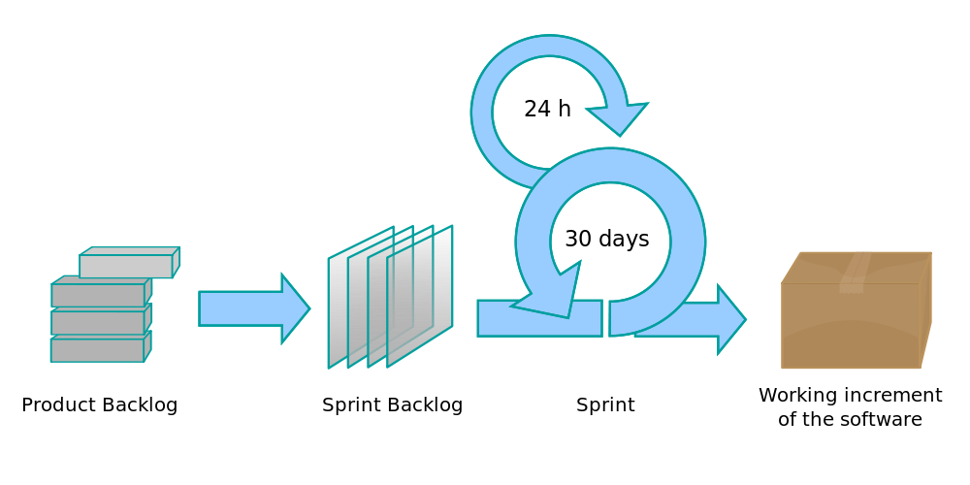

### Tools and Technique

The tools and applications used by the team for this project:

1. Document Development: Microsoft Office Word
2. Communication: Facebook group, Mail and OneDrive to share documents
3. Project Management: Youtrack website.
4. Design software: Adobe Photoshop
5. Programming tools: Android Studio (XML, Java, SQLite), Robo mongo (mongo DB)
6. Server: APIs server.

### Techniques

Document Development: Microsoft Office Word

* All the minutes of meeting, reports and any documents related to this project will be conducted by using MS Word.

Communication: Facebook group, Mail, OneDrive

* All the member in this team project using Facebook as their main social network so choosing to create the message group is a good way to communicate.
* Mail, OneDrive to share all the documents or giving the notices related to the project.

Project Management: using Youtrack template for SCRUM .

* Scrum is our team main method to track down all the tasks during this development. Our team choose to you the free-provided website Youtrack to apply this method.

Design Software: Photoshop

* As a required of the project, design or modify visualizations such as main pages, interface are vital. Our team choose to use Adobe Photoshop as the efficient tools to manage these tasks.

Programming tools: Android Studio (XML, Java, SQLite), Robo mongo (mongo DB)

* Our team use Android Studio to do with XML (for layout), Java (for functions, features) and SQLite (for minor database such as login information).
* Robo mongo is for mongo DB which is to deal with database for the entire product. Therefore, these database will be uploaded to APIs server.

Server service: APIs server.

* All the database will be stored in these APIs server.
* Our team decided to program APIs server.

# Public description

|  |  |
| --- | --- |
|  |  |
| Public description | Group P3 |
| E-mail address of the person in charge: | [duc.phan@edu.turkuamk.fi](mailto:duc.phan@edu.turkuamk.fi) |

# Appendix

Gantt Chart for Turku Market Application.xlsx